DATA CLEANING AND PREPROCESSING

USING PYTHON(PANDAS)

**Task 1:**

To clean the data and preprocess the data.

**Dataset:** sales_data_sample (from Kaggle)

**Dataset Overview**

* The dataset used in this project was sourced from **Kaggle** and contains detailed sales transaction records, including customer information, order details, and shipping addresses.

**Steps of Data Cleaning and Preprocessing**

1. Upload file and import required library (pandas)

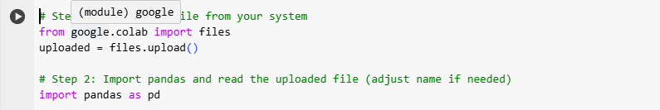

1. Load the data

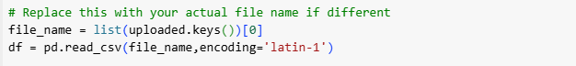

1. Identify and handle the missing data(s)

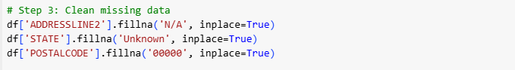

1. View results

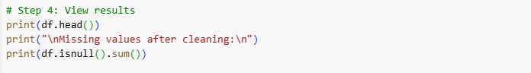

1. Save and download the cleaned file

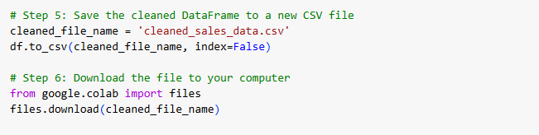

1. To check the cleaned file



**Key Takeaways:**

* How to use python in Data Analytics.
* Use of Pandas library.
* How to Clean and Handle a dataset.
* To sort a dataset.